What are the different booking statuses?
There are 6 different and possible booking statuses as DOTWConnect booking can have, depending on either the travel date or how the availability was taken. The status of a DOTWConnect booking can be seen in the short booking summary of a booking.

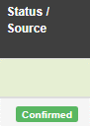
CONFIRMED STATUS: This booking status applies for any pre-travel booking that is taken from a confirmed availability from our suppliers. When this status shows, one has the right to ask assistance from the hotel/suppliers for the booking or ask for the confirmation number.

Lastly, when a booking is in Confirmed Status and the hotel rejects the booking, a WebBeds team member has the right to ask assistance or relocate the guest to another hotel.

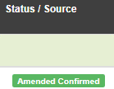
Note: If a booking was successfully amended with confirmed availability, the Confirmed Status will be adjusted to AMENDED CONFIRMED.

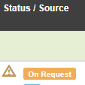
ON REQUEST STATUS: This booking status applies for any pre-travel booking that is taken above confirmed availability or allocation, or if the hotel/room type has been placed on stop sale.

When a booking in on a ON-REQUEST status, the hotel has the right to decline accepting the booking. We can, however, request the hotel if they can accept the booking on the same rate, higher room type or different rate, dependent on their decision. If a hotel is not able to accept an ON-REQUEST booking, the customer would need to create a new booking.

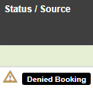
DENIED BOOKING STATUS: This booking status applies for any previous ON-REQUEST booking that has not been accepted by the hotel/supplier, whether on the same rate, higher or different room type or rate. A WebBeds user can change a status from On- Request to Denied booking, via the Enter Reference functionality.

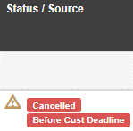
CANCELLED STATUS: This booking status applies for any booking that has been cancelled, prior to the travel date. A booking may either be:

- Cancelled Before Customer Deadline (or without charges), or
- Cancelled After Customer Deadline (or with cancellation charges). This will also be indicated in the booking status.

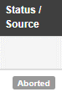
ABORTED STATUS: This booking status applies for bookings or services, wherein the customer/client attempted to book on their end. However, the booking was not completed due to technical reasons. This is equivalent to the Failed Booking status in other WebBeds platforms.

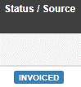
INVOICED STATUS: This is an old booking status in DOTWConnect that used to apply for any booking that is already past the check-in date/time and has not been previously cancelled. Due to these, the hotel/supplier already has the right to request for payment for the booking.

With the recent update of financial systems in DOTWConnect, this status is no longer used for bookings from 2023 onwards.

